Ideation Phase
Empathize & Discover — Empathy Map Canvas
Date | 04 September 2026
Student Name | Pulibanti Tejavani
Project Name | Metro Ticket Generating System
Maximum Marks

Empathy Map Canvas
Dimension | Employee Perspective
Says | I need a simple way to book my metro ticket.
Thinks | I want the correct station, journey type, passenger count, and fare to be selected easily.
Does | Opens the ServiceNow portal, selects the metro ticket service, enters journey details, and submits the request.
Feels | Wants a quick, reliable, and convenient ticket-booking experience.
Pain Points | Incorrect journey details, manual fare calculation, unclear field behavior, and difficulty validating the ticket.
Needs / Goals | Guided ticket booking, automatic fare calculation, validated information, and a digital QR ticket for verification.

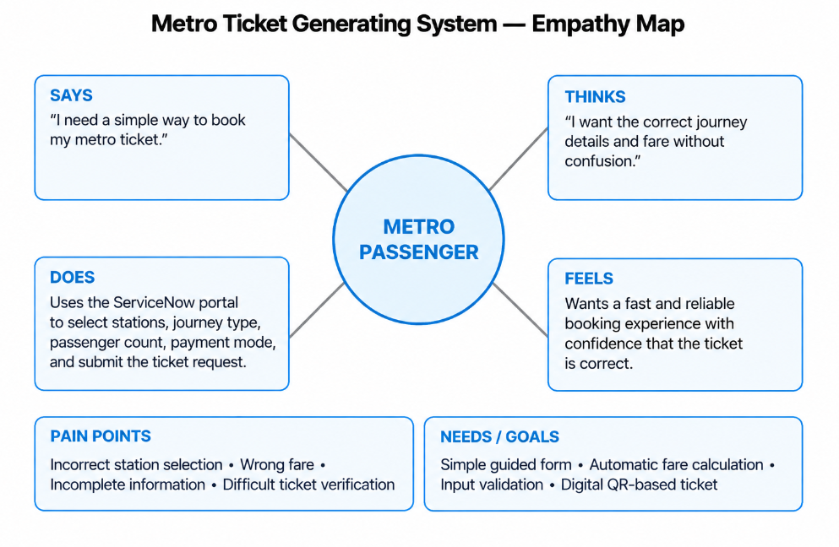

Figure 1: Metro passenger perspective empathy map representation.

